
White Rose Beauty Colleges Application Form 2021-22
Learner details
First Name |  |  |  |  | Middle name (s)
Family Name (Surname) |  |  |  |  | Any previous  Family Name
Title:  (Mr/Mrs/Miss/Ms) |  | Date Of Birth |  |  |  |  |  |  |  | Male Female  Please circle
Address |  |  |  |  |  |  | postcode:  Length of time  at address:
home tel nᵒ |  |  |  | mobile Tel nᵒ
Email |  |  |  | NI Number
Do you have a learning difficulty or disability We are committed to meeting the needs of all students |  |  |  |  |  |  |  |  |  | Yes No
If yes please state
Do you have any medical conditions the college should be aware of to ensure your health and safety whilst on your programme |  |  |  |  |  |  |  |  |  | Yes No
if yes please state condition:
Are you employed? | Name of Employer |  |  |  | Length of Time with current employer |  |  | Length of Time unemployed
Yes No
Do you have any criminal convictions |  |  |  |  |  |  |  |  |  | Yes No
Have you been living in the UK/EEA for the last 3 years? |  |  |  |  |  |  |  |  |  | Yes No
In which Country do you normal live |  |  |  |  |  | What is your Nationality
If you are or have been living overseas please state your date of entry into the UK |  |  |  |  |  | If not English what is the language spoken at home
Please indicate your current status in the UK if not british
How would you describe your ethnic origin? (please tick) We want to check that we are offering equal opportunities to all ethnic groups in the community

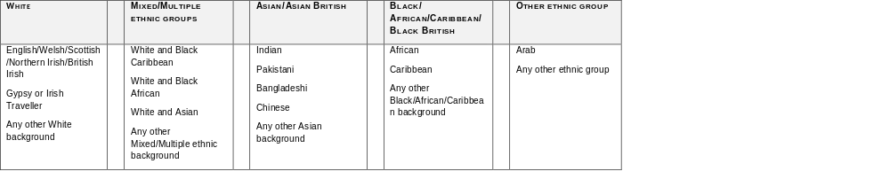

Name of Last School or College attended
Start date (month/year) |  | Leaving date (month/year)
existing Qualifications
Qualification Title | Type  EG: GCSE/BA,BSc | Level |  | Grade  (Predicted grade) | Date Passed  (expected pass date)
Have any of your family studied at university (Please circle) |  |  | yes no
Is a family member dependent on you to care for them (Please circle) |  |  | yes no
Have you ever been in care (Please circle) |  |  | yes no
Area of Study at white rose
Programme Title
Programme Type | Traineeship Apprenticeship Full time college part time college  Please circle
preferred location: |  | Barnsley Chesterfield Derby Doncaster Harrogate Huddersfield Leeds Manchester Sheffield  Please circle
Personal Statement
What career or career change are you aiming for?
Explain briefly why you have applied for this programme
Please explain What work related experience you have (This can be voluntary or paid/ for school leavers this could be work experience)
Data Protection Statement
The White Rose Beauty Colleges use this application form to collect information about you for various administrative, academic and health and safety reasons. This information may be shared with other government and educational organisations for the purposes of administration, careers and other guidance. The Data Protection Act 2018 requires you to sign the following ‘consent to process’ clause and answer the following question. I agree to The White Rose Beauty Colleges processing personal data, including data about my ethnicity, criminal convictions, my learning difficulties & disabilities and medical conditions which The White Rose Beauty Colleges obtains from me or other parties. I agree to the processing of such data for any purposes connected with my course application, my health and safety or any other legitimate reason. The information I have provided to the best of my knowledge is a true and accurate record
Signed (Applicant) |  | Date
OFFICE USE ONLY
Date received: | Interview date/time: | Date acknowledged | College

