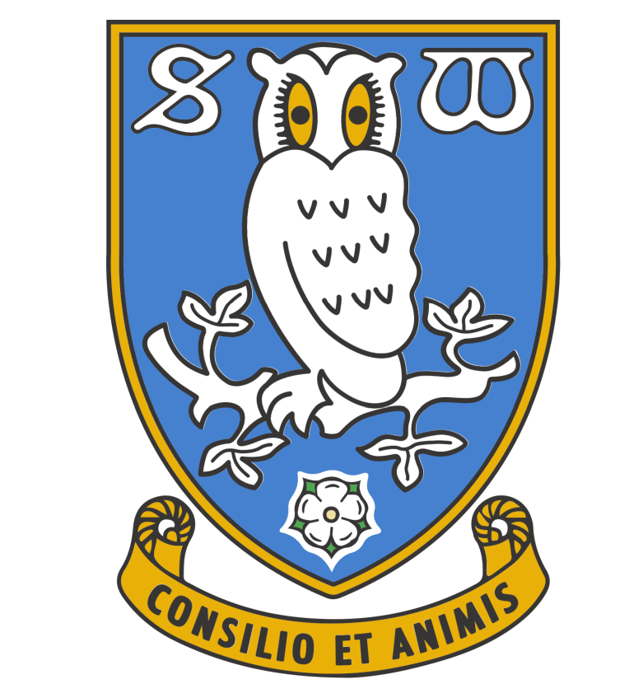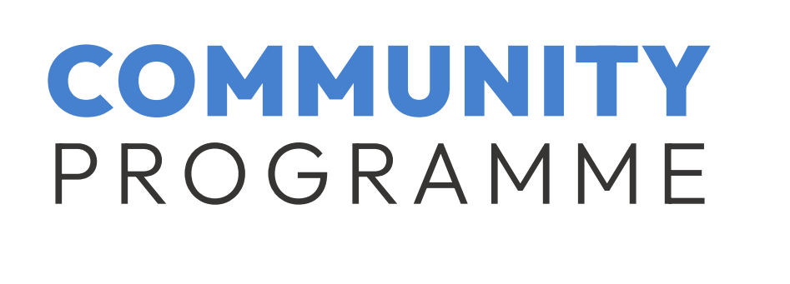SHEFFIELD WEDNESDAY COMMUNITY COLLEGE CONTACT DETAILS

Sheffield Wednesday Education Hub (at the side of the Owls Megastore- next to the
Ticket Office)
Penistone Road North
SHEFFIELD S6 1QB

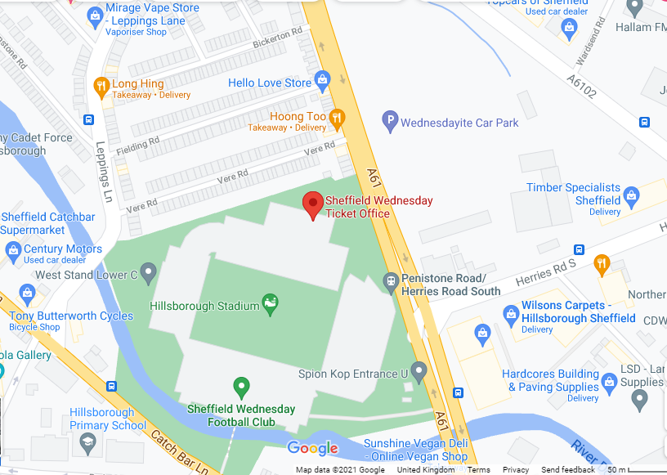

The Education Team
Sheffield Wednesday FC Community Programme
Mobile: 07472 460723
Tel: 0114 3240780
0114 3240779
Email: education@swfc.co.uk



