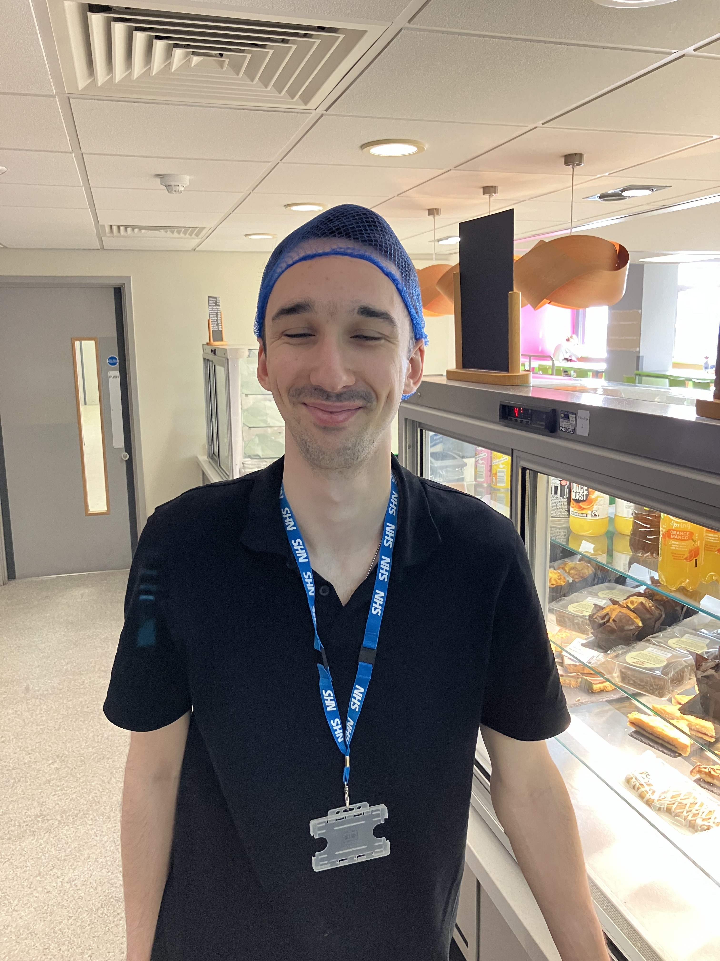
George Secures Employment

George started with Choices College on a Supported Internship in 2023.

Before starting George struggled with his confidence and his ability to communicate professionally and sometimes socially.

George was interested in catering so while with Choices College he completed placements in the catering department at The Royal Hallamshire Hospital and The Sheffield Children’s Hospital.

Below is his testimony:

“I found Choices College really good, and I got on with everyone. I made new friends in the classroom and on placements. I had a laugh with people and learnt a lot.
I did my first placement at the Hallamshire Hospital where I worked on the Deli Bar making sandwiches to order. I also worked in the coffee Bar serving customers and making drinks and I did some work in the pot wash where I cleared the dirty pots from the dining room and took them to the pot wash where I used the large machines to clean and sterilise the pots, plates and cutlery. I then took them back and re stocked them when they were clean.
My second placement at The Sheffield Children’s Hospital was a similar role. I worked in the pot wash, cleared tables, restocked the pots and cutlery and restocked the chilled fridges. I also worked in the prep room where I made sandwiches and breakfast yogurts that go out to be sold. I worked on the servery serving customers hot meals.
I got lots of help and support while I was with Choices College not only in the classroom but on placement as well and I knew Amy and Jo were always there if I needed anything.
With their help I learnt about being in a workplace and how to be employable and from placement I was able to gain the skills I needed to secure paid employment at The Sheffield Children’s Hospital as a Catering Assistant.
When I started, I was very shy but over time and with support I have made friends, become more confident and got a job.
I would recommend Choices College as Amy and Jo are amazing teachers and you do lots of fun activities along the way.
When they found me the placement at The Sheffield Children’s Hospital I didn’t want to leave. It just clicked and I felt like I was at home. I am happy and grateful I have a job with a team I feel is like family.”

