Tom’s Success Story

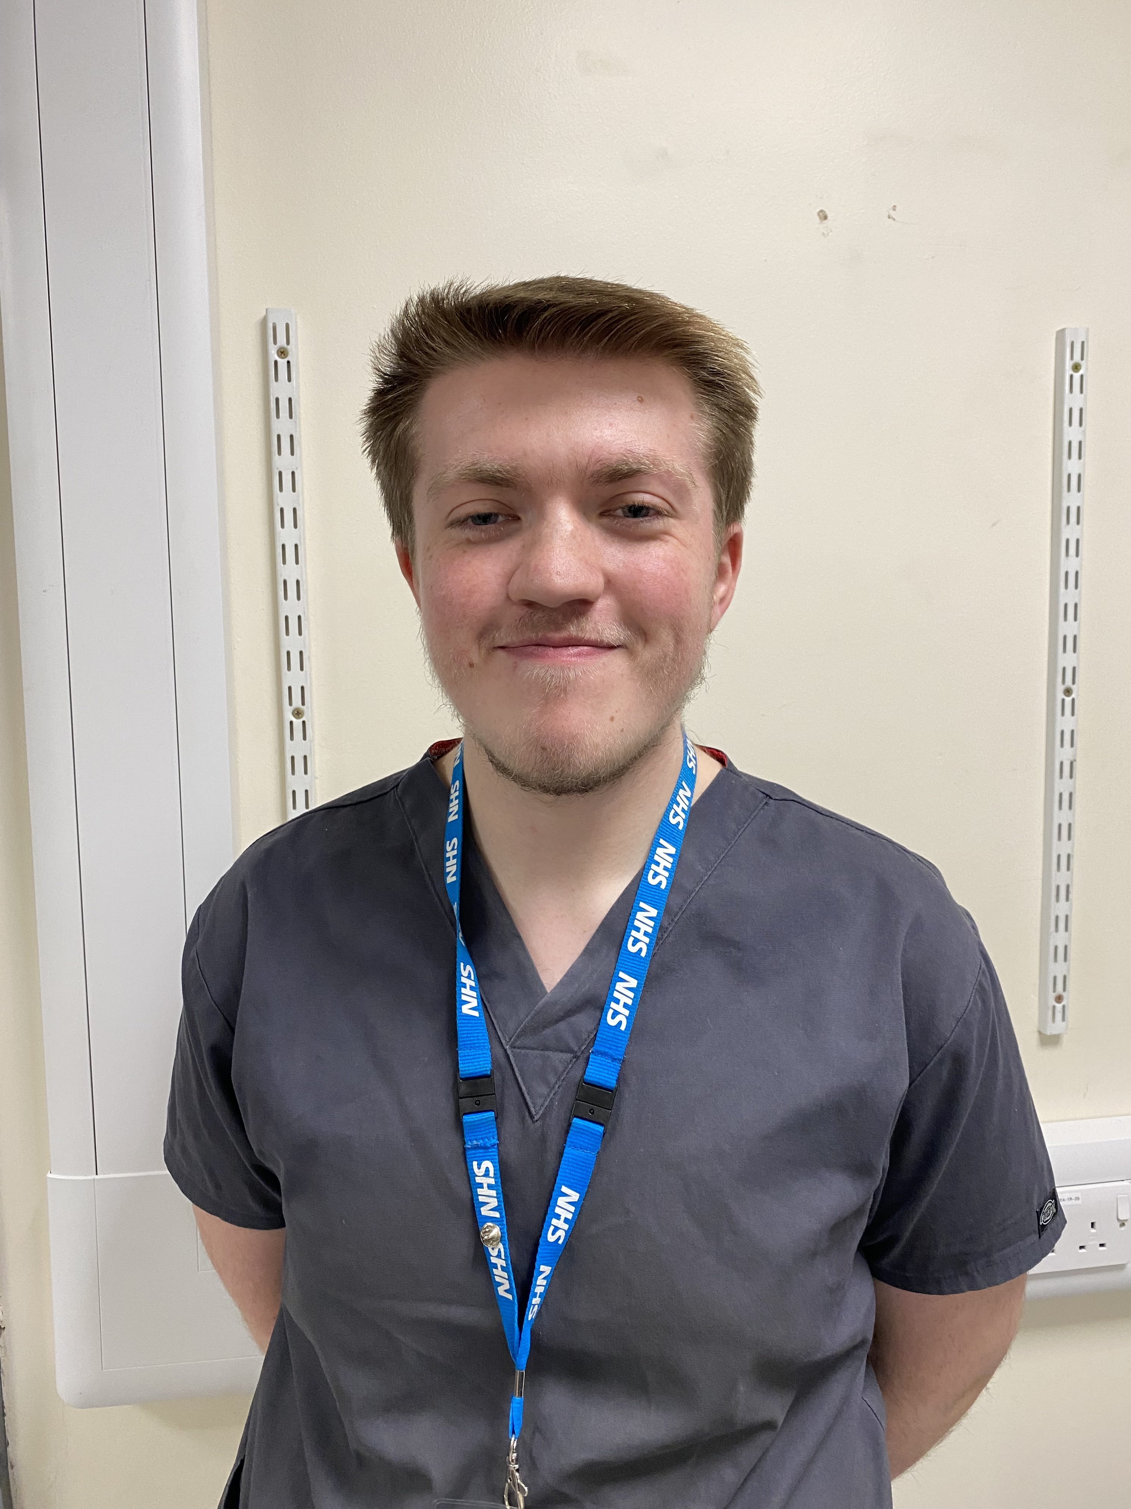
Tom started with Choices College on a Supported Internship in 2022.

Before starting Tom struggled with his social skills and hadn’t enjoyed school or college, leaving early. He was shy and very quiet. As soon as Tom started his first placement, we knew he had so much potential, and it makes us so proud to see how much he has achieved. He is now working within the NHS and is mentoring our current interns.

Below is his testimony:

“I was nervous when I started Choices College and felt anxious about what was to come. As I settled in and got used to the staff and the placement, I felt more relaxed and comfortable. I was treated like an adult and it felt different to being at college. My first placement was with St Lukes in their shop. I felt welcomed and supported by the shop manager and the Choices College staff. I worked in every area of the shop and built enough confidence to be on the till serving customers. I continued to volunteer at St Lukes in my own time as I had enjoyed the placement so much. For my second placement I moved to Theatre Logistics at The Royal Hallamshire Hospital. During my second placement I learnt all about the equipment used in theatres and I felt like I fitted in with the team well. They asked if I would like to stay on for my third placement to learn about Theatre Stores so I could see the whole department. I became more confident and really improved my social skills and my communication skills. Towards the end of my time with Choices College a job came available in my placement. With the support of the College staff, I applied for the job and got an interview. I had support and time to practice for the interview with Amy which paid off as I was offered the job. A year later I applied for a promotion and even though I wasn’t with Choices College anymore I knew they were still there to support me in this next stage. I secured this job, and I’ve settled in well to the role. When Choices College asked if the department would take an intern for this year’s cohort I asked if I could mentor them during their placement. I know how much Choices College supported me, so I wanted to be able to do the same for someone else. I would defiantly recommend Choices College as a Supported Internship. There is so much support and it’s a safe space to be able to explore your interests and your capabilities. It’s a great way to gain all the skills needed to get into work and become a valued member of society.

Sample images. To change picture, right click > Change Picture > From File

