
Sheffield Volunteer
Doula Programme
Can You Become a Volunteer Doula?
Do you have the time and passion to encourage and support vulnerable pregnant women and new mothers?
Would you like to support a woman through her pregnancy, during her birth and feeding and caring for baby?

Volunteers are at the heart of the Doula Programme, and it thrives thanks to their dedication and compassion. They provide essential emotional support and information to expectant mums- from six weeks before birth, during labour if needed, and for six weeks after baby arrives.

If you would like to join the team, training is delivered twice a year to equip you with the knowledge and confidence to support mums in Sheffield. The next training course will start in October 2026.
For more information, please call: 0114 273 5733
Email: doulaproject@sheffield.gov.uk
Visit: https://www.sheffield.gov.uk/home/public-health/doula-volunteer


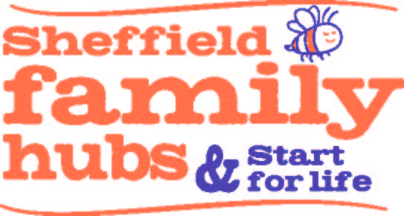
or scan our QR Code

